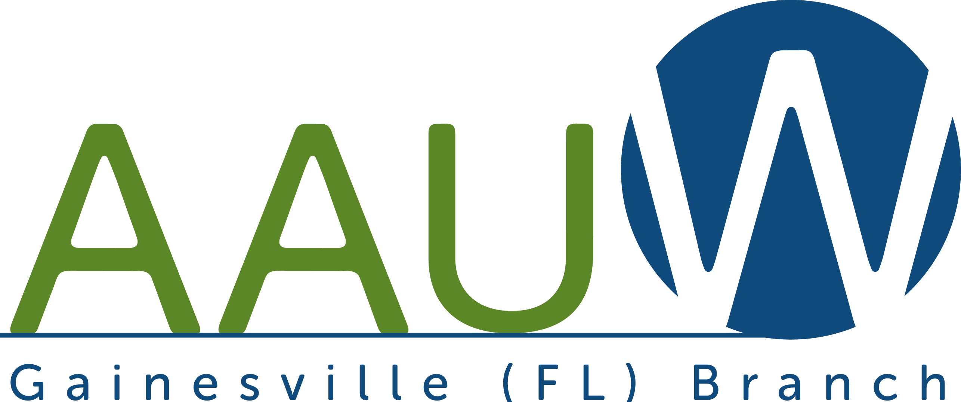

Gainesville AAUW

Programs: 2020-2021

Saturday, September 12, 2020, 10:00 a.m. Donna Waller: Prof. Emerita, Political Science, Santa Fe College. The Power of the Women’s Vote, Zoom meeting, access TBA.
Saturday, October 10, 2020, 10:00 a.m. Dorothy S. Burnham, BS, MA, DMin. Living with Uncertainty, Chaos, and Doubt. Zoom meeting, access TBA.
Saturday, November 14, 2020, 10:00 a.m. Vicky Santello, Retired Senior Vice President - Investments, Merrill Lynch. Tribute to Estelle Aden, 1925-2020. Zoom meeting, access TBA.
Sunday, December 6, 2020, 3-5 p.m. Red Stocking Virtual Tea Party in support of Tech Trek. Zoom meeting, access TBA.
Saturday, January 9, 2021, 10:00 a.m. Carolyn Kershner, J.D. AAUW Research Report - Women's Economic Security in Florida, Zoom meeting, access TBA.

Saturday, February 13, 2021 10:00 a.m. Souad Kheder, PhD. Language and Cognition, Zoom meeting, access TBA.
Saturday, March 13, 2021 10:00 a.m. Barbara Oberlander, Prof. Emerita, History, Santa Fe College. Shirley Chisholm: She Started It All. Zoom meeting, access TBA.
Saturday, April 10, 2021, 11:30 a.m. Annual Branch Dutch Luncheon and election of officers. Location: Restaurant, TBA.
Saturday, May 15, 2021, 11:30 a.m. Annual Pot Luck Picnic, Installation of officers, white elephant sale. Location: TBA.

Branch Website Address: https://gainesville-fl.aauw.net

Branch Facebook Page:
www.facebook.com/groups/ aauwgainesvillefl

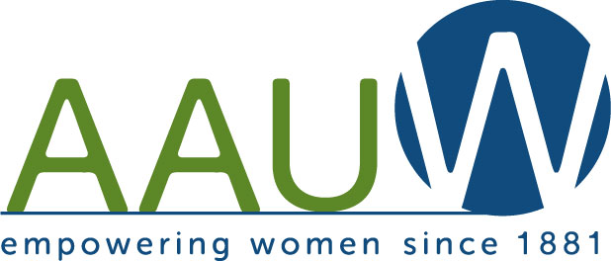
www.aauw.org
How Do I Join the Gainesville
Branch of AAUW?

Return Information and Dues to:

Ms. Carolyn Iadovito AAUW Branch Membership Director 9804 SW 34th Road Gainesville, FL 32608 (352) 505-6901; clicbi@aol.com
Name: ____________________________________________
Address: _________________________________________
City/Zip: _________________________________________
Phone: ___________________________________________
Email: ____________________________________________
College/University/Degree(s)/Majors:
____________________________________________________
____________________________________________________
____________________________________________________
2020-21: National dues, $59; State dues, $12, Branch dues, $15. Total: $86.00. Make check payable to AAUW, Gainesville, FL

AAUW Dedication
AAUW has been dedicated to advancing opportunity and equality since 1881. At that time it was believed that higher education for women was harmful to the good of society and to individual women's health! AAUW has discredited such ideas for 139 years and has joined women together to accomplish the following:

- Champion equitable compensation and treatment.

- Support accessible, affordable, high-quality education for all women and girls.

- Advocate for women's career, financial, and life choices.

- Develop and motivate leaders by researching educational and economic barriers for women and girls.

- Promote challenging careers as a means to improve quality of life.

- Foster networks that help women succeed.

AAUW Membership
Membership is open to all graduates holding an associate or equivalent, baccalaureate, or higher degree from a qualified educational institution or a foreign degree acceptable as a basis for admission by graduate schools at qualified universities of the United States. You can join AAUW at the national level, but by belonging to the local branch you are provided with more networking opportunities. Branch members also belong to the national organization.
Why Should I Join the
Gainesville Branch?
Here is why!

- By joining AAUW, you belong to a community that breaks through educational and economic barriers so that all women and girls have a fair chance.

- In principle and in practice, AAUW values and seeks a diverse membership. There shall be no barriers to full participation in this organization on the basis of gender, race, creed, sexual orientation, national origin, disability, or class. AAUW members are inter-generational and international.

- AAUW provides interesting programs that challenge your thinking and encourage you to understand your world.

American Association
of University Women

AAUW
Breaking through
Barriers for
for Women and Girls

Gainesville, FL Branch
2020-2021

